Passport to Europe Homework- Class 4 - 6 pieces due in by February half term.
Practice your times tables and spellings every week. Please also read at home at least 3 times a week.
Art  Choose a Claude Monet painting and attempt to recreate it using the  medium of your choice.  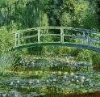  (pens/paints/pastels etc) | French  Learn some French words  and make a French dictionary to record what you have learnt. | English  Write a list of at least 5 questions that you would  like to ask a Spanish person.  Tell us why do you want to know these facts.
Geography/Maths  Create a weather chart comparing Walton to a city in France.  Show the differences in temperature and rainfall across the 12 months of the year. | Maths  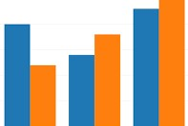  Create a bar graph showing the population of a number of European countries. | English  Write a poem about Spain.  This can be any type of poem (acrostic, free verse etc),
PE  Many European countries are known for having great football teams!  Create a training routine that the players could follow to help build their fitness and skills. Include pictures of you doing the training if you can or draw yourself. | English/Geography/History  Create a leaflet about a European country of your choice. Remember to include factual language and pictures. | DT  Choose a European landmark and attempt to build it using a variety of materials.  

